[**05 -Listin Python**](https://www.rajalakshmicolleges.net/moodle/course/view.php?id=84&section-5)

**Ex. No. : 5.1 Date: 8/5/24**

**Register No.: 231801160 Name: Sathvikha**

## BalancedArray

Given an array of numbers, find the index of the smallest array element (the pivot), for which the sums of all elements to the left and to the right are equal.The array may not be reordered.

Example arr=[1,2,3,4,6]

* thesumofthe firstthree elements,1+2+3=6.Thevalueofthelastelementis6.
* Usingzerobasedindexing,arr[3]=4isthepivotbetweenthetwosubarrays.
* Theindexofthepivotis3. Constraints
* 3≤ n≤ 105
* 1≤arr[i]≤2×104,where0≤i<n
* Itisguaranteedthatasolutionalwaysexists.

Thefirstlinecontainsanintegern,thesizeofthearrayarr.

Eachofthenextnlinescontainsan integer,arr[i],where0≤ i< n. Sample Case 0

SampleInput0

4

1

2

3

3

SampleOutput0

2

Explanation0

Thesumofthefirsttwoelements,1+2=3.The value ofthelastelementis3 Using zerobased indexing,arr[2]=3 isthepivot betweenthetwosubarrays The index of the pivot is 2

SampleCase1

SampleInput1

3

1

2

1

SampleOutput1

1

Explanation1

Thefirstandlastelementsareequalto1

Usingzerobasedindexing,arr[1]=2isthepivotbetweenthetwosubarrays The index of the pivot is 1.

**For example:**

|  |  |
| --- | --- |
| **Input** | **Result** |
| 4  1  2  3  3 | 2 |
| 3  1  2  1 | 1 |

# Program:

a=int(input()) l=[]

foriinrange(a): c=int(input()) l.append(c)

foriinrange(1,a): d=sum(l[0:i])

r=sum(l[i+1:]) if(d==r):

print(i)

# Output:

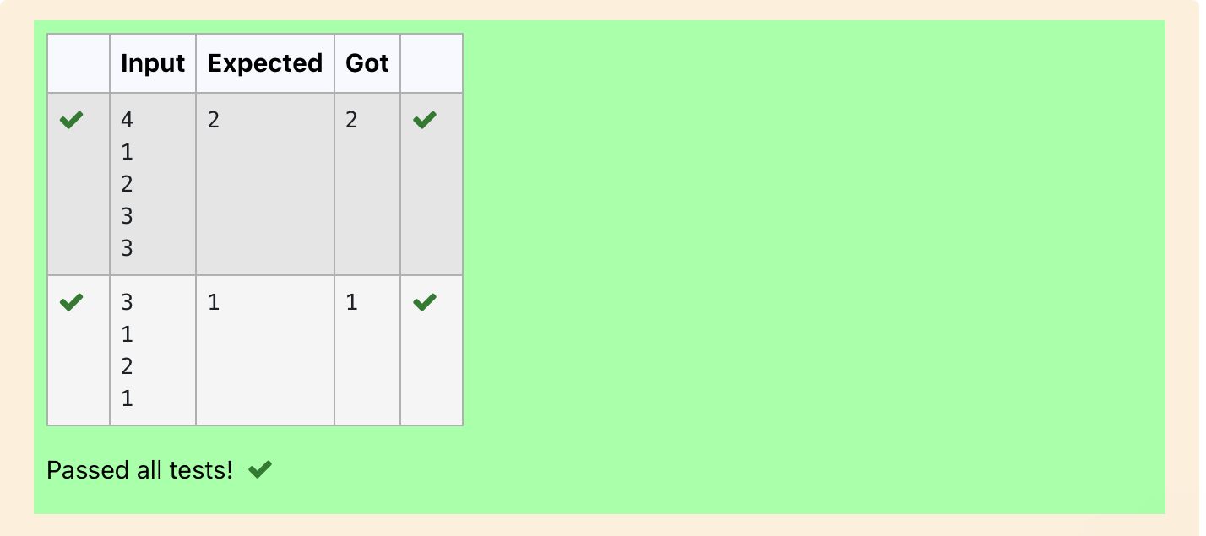

**Ex. No. : 5.2 Date: 8/5/24**

**Register No.: 231801160 Name: Sathvikha**

## Checkpairwithdifference k

GivenanarrayAofsortedintegersandanothernonnegativeintegerk,findifthere exists 2 indices i and j such that A[i] - A[j] = k, i != j.

Input Format

1. Firstlineis numberoftestcasesT.FollowingTlines contain:
2. N,followedbyNintegersofthearray
3. Thenon-negativeintegerk Output format

Print 1 if such a pair exists and 0 if it doesn’t Input

1

3

1

3

5

4

Output:

1

Input 1

3

1

3

5

99

Output 0

**For example:**

|  |  |
| --- | --- |
| **Input** | **Result** |
| 1  3  1  3  5  4 | 1 |

|  |  |
| --- | --- |
| **Input** | **Result** |
| 1  3  1  3  5  99 | 0 |

# Program:

a=int(input()) while(a!=0):

b=int(input()) l=[]

f=0

foriinrange(b): c=int(input()) l.append(c)

k=int(input()) a-=1

for i in range(b): forjinrange(b):

if(l[i]-l[j]==kandi!=j): f=1

break if(f==1):

print(1) else:

print(0)

# Output:

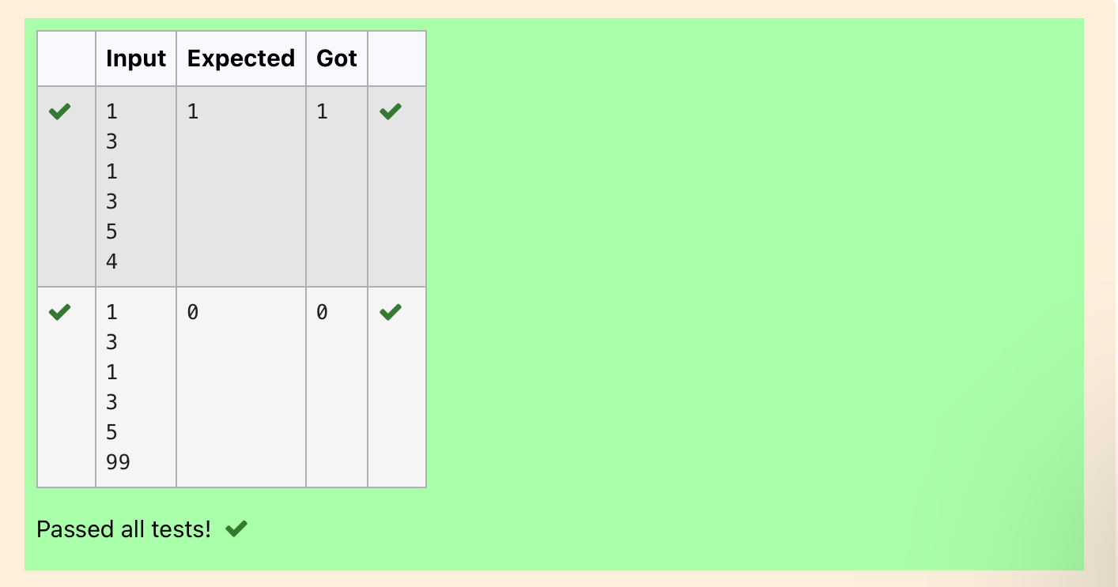

**Ex. No. : 5.3 Date: 8/5/24**

**Register No.: 231801160 Name: Sathvikha**

## CountElements

Complete the program to count frequency of each element of an array. Frequency of a particular element will be printed once.

SampleTestCases Test Case 1

Input 7

23

45

23

56

45

23

40

Output

23occurs3times

45occurs2times

56occurs1times

40occurs1times

# Program:

importcollections

defCountFrequency(arr):

returncollections.Counter(arr)

ifname=="main": # Input size of array n = int(input())

#Inputelementsinarray arr = []

for_in range(n):

ele=int(input()) arr.append(ele)

#Calculatefrequencyofeachelement freq = CountFrequency(arr)

for key, value in freq.items(): print(f"{key}occurs{value}times")

# Output:

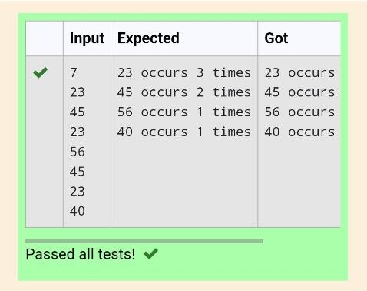

**Ex. No. : 5.4 Date: 8/5/24**

**Register No.: 231801160 Name: Sathvikha**

## DistinctElementsinanArray

Programtoprintallthedistinctelementsinanarray.Distinctelementsarenothingbut the unique (non-duplicate) elements present in the given array.

InputFormat:

FirstlinetakeanIntegerinputfromstdinwhichisarraylengthn. Second line take n Integers which is inputs of array.

OutputFormat:

PrinttheDistinctElementsinArrayinsinglelinewhichisspaceSeparated

ExampleInput: 5

1

2

2

3

4

Output:

1234

ExampleInput: 6

1

1

2

2

3

3

Output:

123

Forexample: Input Result 5

1

2

2

3

4

1234

6

1

1

2

2

3

3

123

# Program:

defmerge_arrays_without_duplicates(arr1,arr2):

#Combinethearraysandconverttoasettoremoveduplicates result_set = set(arr1 + arr2)

# Convert the set back to a sorted list merged_sorted_array=sorted(result_set) return merged_sorted_array

#Inputreadandprocessing def process_input():

#Readingnumberofelementsandtheelementsforthefirstarray n1 = int(input())

array1=[]

for _ in range(n1):element = int(input()) array1.append(element)

#Readingnumberofelementsandtheelementsforthesecondarray n2 = int(input())

array2=[]

for _ in range(n2): element=int(input())

array2.append(element)

#Mergethearrayswithoutduplicates

result=merge_arrays_without_duplicates(array1,array2) # Print the result

print("".join(map(str,result)))

# Output:

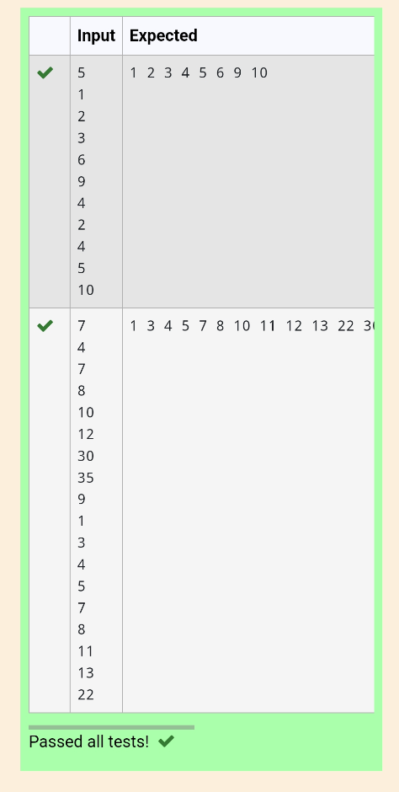

**Ex. No. : 5.5 Date: 8/5/24**

**Register No.: 231801160 Name: Sathvikha**

## ElementInsertion

Consideraprogramtoinsertanelement/iteminthesortedarray.Completethelogicby filling up required code in editable section. Consider an array of size 10. The eleventh item is the data is to be inserted.

SampleTestCases Test Case 1

Input 1

3

4

5

6

7

8

9

10

11

2

Output

ITEM to be inserted:2 Afterinsertionarrayis: 1

2

3

4

5

6

7

8

9

10

11

TestCase2 Input

11

22

33

55

66

77

88

99

110

120

44

Output

ITEM to be inserted:44 Afterinsertionarrayis: 11

22

33

44

55

66

77

88

99

110

120

# Program: Output:

definsert_sorted(list,n):

list.append(n) sorted_list=sorted(list)

print("Afterinsertionarrayis:") for i in range(11):

print(sorted_list[i])

sorted_list=[int(input())foriin range(10)]

new_element=int(input())

print("ITEMtobeinserted:", new_element, sep='')

insert_sorted(sorted_list, new_element)

**DepartmentofComputerScienceandEngineering**|**RajalakshmiEngineeringCollege**

**Ex. No. : 5.6 Date: 8/5/24**

**Register No.: 231801160 Name: Sathvikha**

## FindtheFactor

Determine the factors of a number (i.e., all positive integer values that evenly divide into a number) and then return the pthelement of the[list](http://118.185.187.137/moodle/mod/resource/view.php?id=732), sorted ascending. If there is no pthelement, return 0.

**Constraints**

1≤n≤1015

1≤p≤109

Thefirstlinecontainsanintegern,thenumbertofactor.

Thesecondlinecontainsanintegerp,the1-basedindexofthefactortoreturn.

**SampleCase0**

**SampleInput0**

10

3

**SampleOutput0**

5

**Explanation0**

Factoringn=10results in{1,2, 5,10}.Returnthep =3rdfactor,5,asthe answer.

**SampleCase1**

**SampleInput1**

10

5

**SampleOutput1**

0

**Explanation1**

Factoringn=10results in{1,2, 5,10}.There areonly4factorsandp=5, therefore 0 is returned as the answer.

**SampleCase2**

**SampleInput2**

1

1

**SampleOutput2**

1

**Explanation2**

Factoringn=1resultsin {1}.Thep=1stfactorof1is returnedasthe answer.

**For example:**

|  |  |
| --- | --- |
| **Input** | **Result** |
| 10  3 | 5 |
| 10  5 | 0 |
| 1  1 | 1 |

# Program:

import sys importmath

deffind_factors(n):

factors=[]

foriinrange(1,int(math.sqrt(n))+1): if n % i == 0:

factors.append(i) if i != n // i:

factors.append(n//i) return sorted(factors)

def get_pth_factor(n, p): factors=find_factors(n) if p <= len(factors): return factors[p - 1] else:

return 0

#Readinginputdirectly fromthestandardinput(typicallyforcompetitive programming)

input=sys.stdin.read data = input().split()n = int(data[0])

p=int(data[1])

#Calculateandprintthep-thfactor print(get_pth_factor(n, p))

# Output:

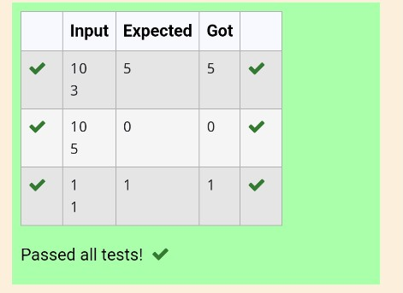

**Ex. No. : 5.7 Date: 8/5/24**

**Register No.: 231801160 Name: Sathvikha**

## MergeList

WriteaPythonprogramtoZiptwogivenlistsoflists.

Input:

m : row sizen:columnsize

list1andlist2:Twolists Output

ZippedList:Listwhichcombinedbothlist1andlist2 Sample test case

Sample input

2

2

1

3

5

7

2

4

6

8

Sample Output

[[1,3,2,4],[5,7,6,8]]

# Program:

defzip_lists(list1,list2):

return[row1+row2forrow1,row2inzip(list1,list2)]

defmain():

m=int(input())

n = int(input())

list1=[[int(input())for_inrange(n)]for_inrange(m)] list2=[[int(input())for_inrange(n)]for_inrange(m)]

zipped_list=zip_lists(list1,list2) print(zipped_list)

if name =="main": main()

# Output:

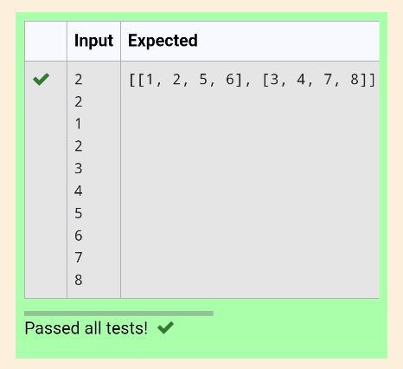

**Ex. No. : 5.8 Date: 8/5/24**

**Register No.: 231801160 Name: Sathvikha**

## MergeTwoSortedArraysWithoutDuplication

Outputisamergedarraywithoutduplicates. Input Format

N1-noofelementsinarray1 Array elements for array 1 N2-noofelementsinarray2 Array elements for array2 Output Format

Displaythemergedarray Sample Input 1

5

1

2

3

6

9

4

2

4

5

10

SampleOutput1

123456910

# Program:

defmerge_arrays_without_duplicates(arr1,arr2):

#Combinethearraysandconverttoasettoremoveduplicates result_set = set(arr1 + arr2)

# Convert the set back to a sorted list merged_sorted_array=sorted(result_set) return merged_sorted_array

#Inputreadandprocessing

defprocess_input():

#Readingnumberofelementsandtheelementsforthefirstarray n1 = int(input())

array1=[]

for _ in range(n1):element = int(input()) array1.append(element)

#Readingnumberofelementsandtheelementsforthesecondarray n2 = int(input())

array2=[]

for _ in range(n2):element = int(input()) array2.append(element)

#Mergethearrayswithoutduplicates

result=merge_arrays_without_duplicates(array1,array2)

#Printthe result

print("".join(map(str,result)))

# Output:

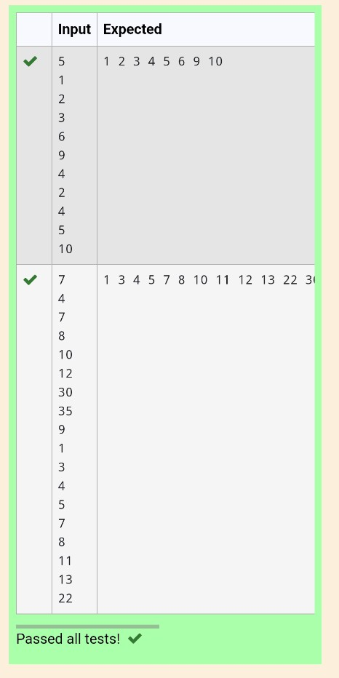

**Ex. No. : 5.9 Date: 8/5/24**

**Register No.: 231801160 Name: Sathvikha**

## PrintElementLocation

Writeaprogramtoprintallthelocationsatwhichaparticularelement(takenas input) is found in a list and also print the total number of times it occurs in the list. The location starts from 1.

Forexample,ifthereare4elementsinthearray: 5

6

5

7

Iftheelementtosearchis5thentheoutputwillbe: 5 is present at location 1

5ispresentatlocation3

5ispresent2timesinthearray. Sample Test Cases

TestCase1 Input

4

5

6

5

7

5

Output

5ispresentatlocation1.

5ispresentatlocation3.

5ispresent2timesinthearray.

TestCase2 Input

5

67

80

45

97

100

50

Output

50isnotpresentinthearray.

# Program:

deffind_element_locations(lst,target): locations = []

count=0

foriinrange(len(lst)): if lst[i] == target:

locations.append(i+1)

count+=1

returnlocations,count

defmain():

n = int(input())

lst=[int(input())for_inrange(n)] target = int(input())

locations,count=find_element_locations(lst,target)

ifcount== 0:

print(f"{target}isnotpresentinthearray.") else:

forlocinlocations:

print(f"{target} is present at location {loc}.") print(f"{target}ispresent{count}timesinthearray.")

if name =="main": main()

# Output:

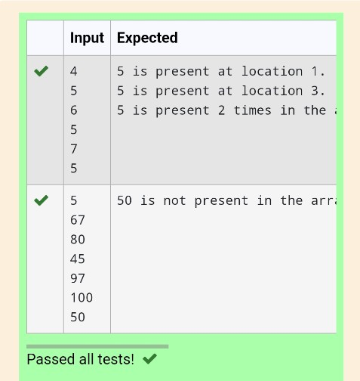

**Ex. No. : 5.10 Date: 8/5/24**

**Register No.: 231801160 Name: Sathvikha**

## Strictlyincreasing

WriteaPythonprogramtocheckifagivenlistisstrictlyincreasingornot.Moreover, Ifremovingonlyoneelementfromthelistresultsinastrictlyincreasinglist,westill consider the list true

Input:

n:Numberofelements List1: List of values Output

Print"True"iflistisstrictlyincreasingordecreasingelseprint"False"

SampleTestCase Input

7

1

2

3

0

4

5

6

Output True

# Program:

n=int(input())

arr=[int(input())foriinrange(n)] l = arr.copy()

g=0

size = len(arr) arr_asc=sorted(arr)

arr_des=sorted(arr)[::-1]

ifarr==arr_ascorarr==arr_des: print('True')

g=1 else:

for i in arr: l.remove(i) arr_asc.remove(i) arr_des.remove(i)

ifl==arr_ascorl==arr_des: print('True')

g=1 break

l=arr.copy()

arr_asc = sorted(arr) arr_des=sorted(arr)[::-1]

if g==0:

print('False')

Output:

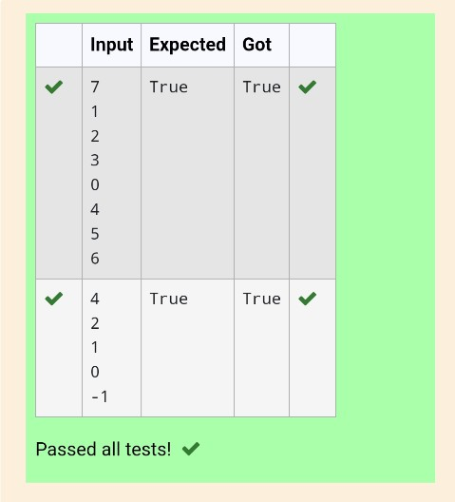

**DepartmentofComputerScienceandEngineering**|**RajalakshmiEngineeringCollege**

.